CS5590/490-Python/Deep Learning

DL- ASSIGNMENT-2

By: Syed Jawad Hussain Shah

Student ID: 16117985

Class ID: 46

**Author:** Syed Jawad Hussain Shah

**Introduction:**

Convolutional neural network (CNN) is a one of the type of the deep learning artificial neural network suites that works on feed forward mechanism. Like other neural networks, CNN are inspired from biological process in neuron. Although CNN is widely use for image classification, its application also includes text classification.

**Objective:**

The objective of this lab task is to get familiar with CNN and its implementation in python by using TensorFlow library. The features of this lab include to write a program to implement a CNN on a data with minimum of 5 classes for text classification in python using TensorFlow, NumPy, and other relevant python libraries. It was also desired to reduce the error of the model by increasing learning rate. The graphs of this program were written in an event file and were viewed in the TensorBoard by writing a command in the python terminal. The last part of the task was to change the hyperparameter of the initial program the compare the difference between the accuracy of the two approaches.

**Approaches/Methods:**

The approach used in this program is to implement Convolutional neural network (CNN) model on the data for text classification purposes. The data used is taken from Consumer Financial Protection Bureau(CFPB)database. This database contains complaints from consumer on financial issues. The model was initially trained and then predictions were made on the basis of training and weight was set accordingly to improve the model accuracy.

**Workflow:**

1. Libraries were imported

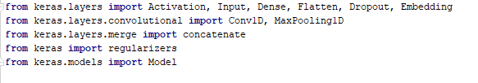

1. CNN model was defined:

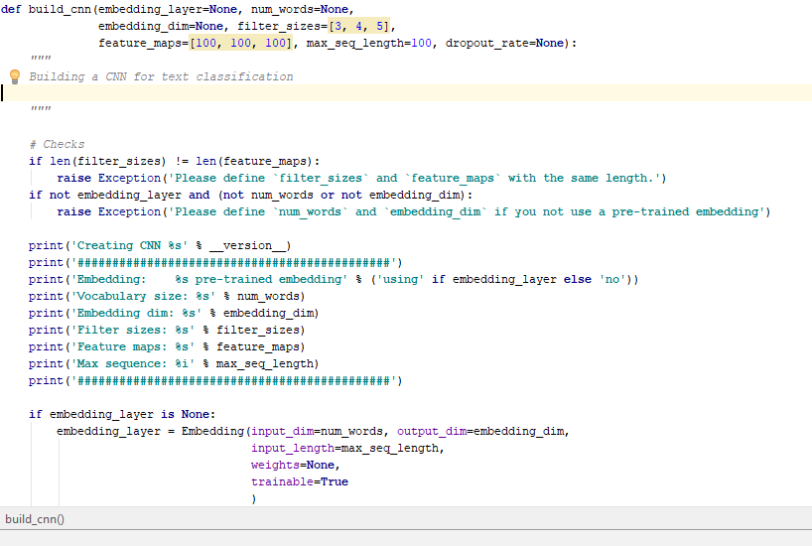

1. Parameters were defined for the model

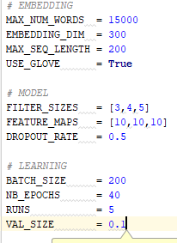

1. Model accuracy was calculated:

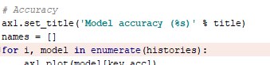

1. The model score, and loss was calculated:

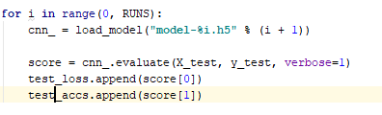

|  |  |
| --- | --- |
|  |  |

**Datasets:**

The data used is taken from Consumer Financial Protection Bureau(CFPB)database. This database contains complaints from consumer on financial issues. The Data contains 9 classes and therefore meet the requirement of minimum 5 classes set for this assignment.

**Parameters:**

The parameters used are as following:



**Evaluation and discussion:**

Unlike other neural networks, CNN neurons are arranged in three dimensions, width, depth, height. Convolutional neural network (CNN) works on feed forward mechanism, therefore, it was noticed that the model accuracy increased with the increasing of training steps. This shows that model was learning good and was improving its accuracy on base of that learning. The reduction in the loss was also a clear indicator of this observation. Overall the model was a good model with the average loss of 17.93% and average accuracy of 93.93 %.

**Conclusion:**

The model average accuracy was 93.93 % which shows that this approach is quite reliable and can be used to classify more of the similar data. However, when the number of turns (epochs) was put less than 10 to change the hyperparameters, the accuracy fell to below than 90 %, which means that model performs better with more repetitions. The graphs of the model can be seen on TensorBoard. The screenshots of TensorBoard Graph is pasted along with results below:

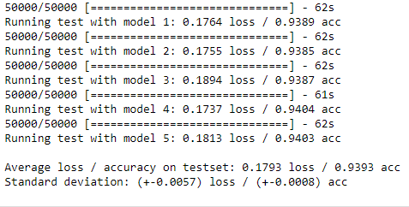

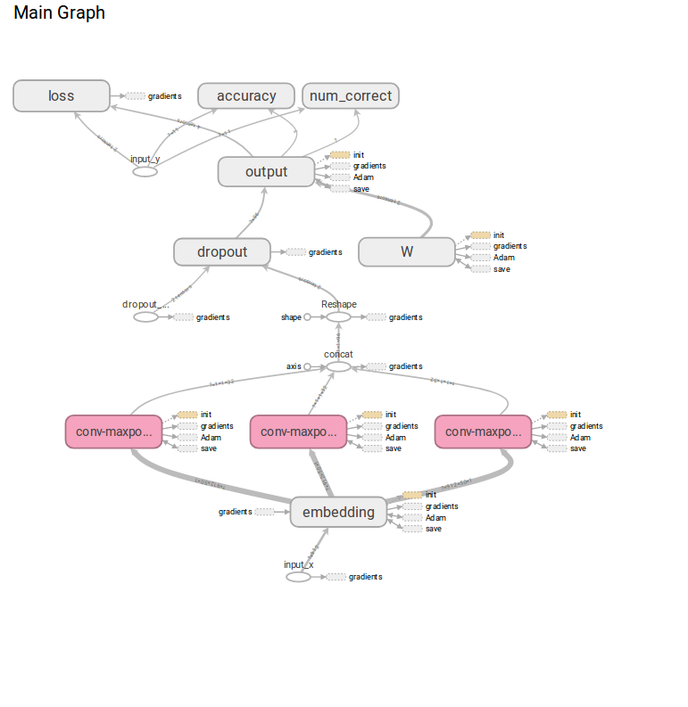

**References**

<https://opensource.com/article/17/11/intro-tensorflow>

<https://learningtensorflow.com/Visualisation/>

<https://github.com/cmasch/cnn-text-classification>